

Sukkur IBA University

Department of Computer Science
Applied Physics, Spring 2024

Lab-10: To perform Half Wave and Full Rectification using NI-Elvis Kit and Multisim

Instructor: Engr. Asif Ali

Note: Submit this lab hand-out in the next lab with attached solved activities and exercises.
Submission Profile
Name: Submission date:
Enrollment ID: Receiving authority name and signature:
Comments: __________________________________________________________________________
Instructor Signature

Lab Learning Objectives:
After completing this session, students will be able:

- To understand the operation of half wave rectification and full wave rectification.
- To Design Half wave rectification and full wave rectification circuit on Multisim.

Lab Hardware and Software Required:
- NI ELVIS II
- NI ELVISmx Instrument Launcher
- Multisim
- Resistors
- Diodes
- Voltage supply (AC)
- Voltmeter
- Oscilloscope

Background Theory:
A rectifier is a circuit that converts pulsing ac into pulsing dc. There are three basic types of rectifier circuits: the half wave, full wave (center tapped) and bridge rectifiers. Of them, bridge rectifier is the most commonly used.
HALF WAVE RECTIFIER:
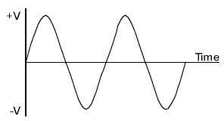
Half wave rectification is a process, which converts an AC sinusoidal input voltage into a pulsing dc voltage with the output pulse occurring for each input cycle. The half wave rectifier is made up of a single diode and a resistor (load). The half wave rectifier conducts the current only during the positive half cycle of the ac input supply. The negative half cycle of ac supply is suppressed i.e., during the negative half cycle, no current is conducted and hence no voltage appears across the load. Therefore, current always flows in one direction (i.e. dc) through the load after every half cycle.


Full Wave Rectification using BRIDGE RECTIFIER: During the positive half cycle of A.C input voltage diodes D4 and D5 are forward biased and conduct current .At this time a voltage is developed across Rl which looks like the positive half of the input cycle. When input cycle is negative, the diodes D6 and D7 are forward biased and conduct current in same direction through Rl as during positive half cycle. During the negative half cycle diodes D4 and D5 are reverse biased. When we combine the output of positive and negative half cycle, the resulting wave looks like as shown in the fig:
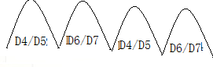

Lab Exercises:
- Design half wave rectification and full wave rectification on Multisim.

HALF WAVE RECTIFICATION
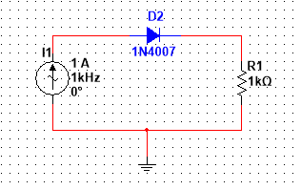

FULL WAVE RECTIFICATION
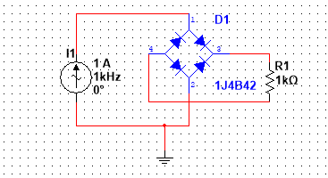

Review Questions:
- What are the applications of half wave rectification?
  - Battery charging
  - Small power supplies
  - Signal demodulation
  - Heating applications

- How half wave rectification works?
Half-wave rectification works by allowing current to flow through a circuit in only one direction during one half of the AC cycle. When the AC voltage is positive, the diode conducts and allows current to flow through the load. However, when the AC voltage becomes negative, the diode blocks the flow of current, resulting in a pulsating DC output consisting of only the positive half-cycles of the input AC voltage.

- What are the advantages and disadvantages of half wave rectifier?
Advantages:
- Simple and inexpensive circuitry
- Easy to implement
- Suitable for low-power applications
Disadvantages:
- Inefficient, as it utilizes only half of the AC cycle
- Produces a pulsating DC output with significant ripple
- Limited applications due to its inefficiency and pulsating output

